Prince Singhal

Princesinghal207@gmail.com

Wireframe document

Thyroid Disease Detection

**Homepage**

We have divided Thyroid Disease Detection’s homepage into two sections: -

1. First thing anyone will see on viewing the URL address is the homepage. It will ask the user to enter the details of hormone level and age of the patient.

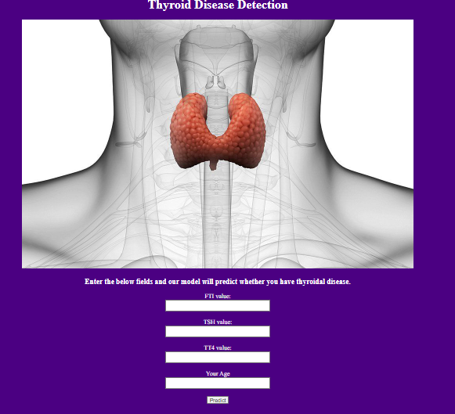

1. After the user enter the details and hits the predict the output will be shown as given below:

